CONFIGURE DHCP SERVER

How to configure DHCP on Layer 3 switch

Inacio Andre

2024

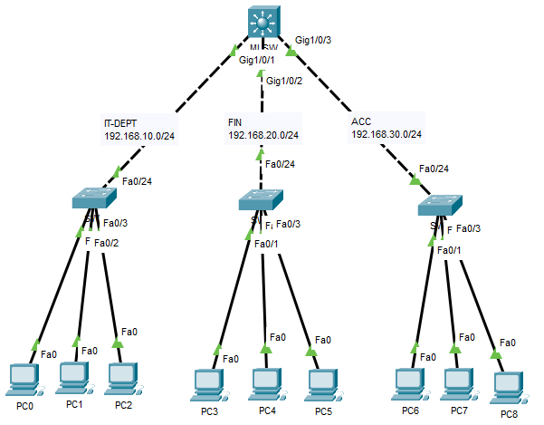

MLSW

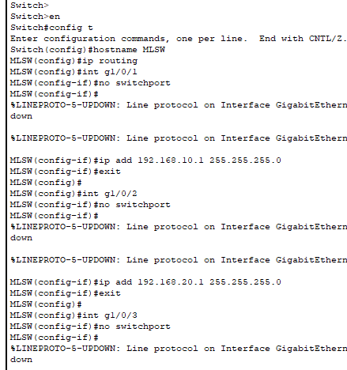

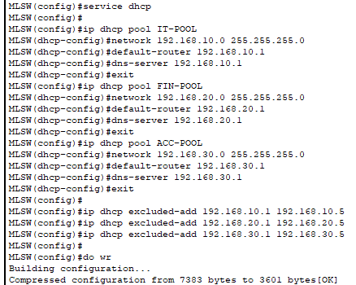

PC0

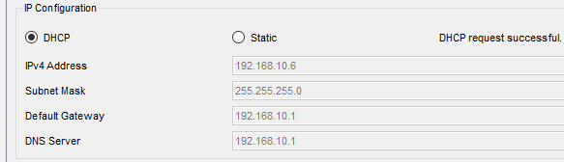

PC3

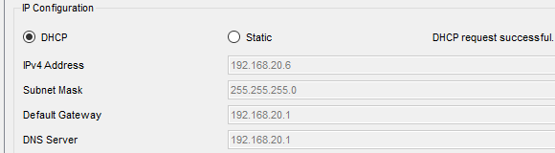

PC6

